Boot Procedure manual

Version 1.0


Tismo Technology Solutions (P) Ltd.
22/2, Palmgrove Road
Bangalore 560047, INDIA

Confidential
This document contains confidential information of Tismo. In consideration of receipt of this document, the recipient agrees to maintain such information in confidence and to not reproduce or otherwise disclose this information to any person outside the group directly responsible and authorized to use its contents, except that there is no obligation to maintain the confidentiality of any information which was known to the recipient prior to receipt of such information from Tismo, or becomes publicly known through no fault of recipient, or is received without obligation of confidentiality from a third party.

Table of Contents
1 Initial checks 5
1.1 FW check on Fresh board or SPI erased boards 5
1.2 FW check on SPI Flashed boards 7

Table of Figures

Error! No table of figures entries found.
List of tables

Error! No table of figures entries found.

Revision History
Version Number | Date | Changes | Author | Reviewed By | Approved By
1.0 | 01-Sep-25 | Initial Version | Nishma N J | Saravana S | NA

Initial checks

FW check on Fresh board or SPI erased boards
Check if the device is in Boot mode
Steps :
- Open Cypress IDE, and click on the USB Control center
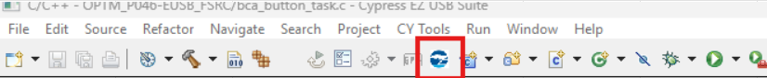
- Check if the board is in boot mode?
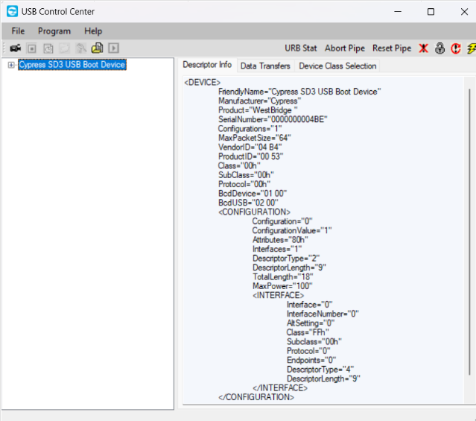
- If the board is a Fresh board, this is expected to be in boot mode.
- Now go to Program -> FX3 -> SPI Flash and select the .img file to flash the board.
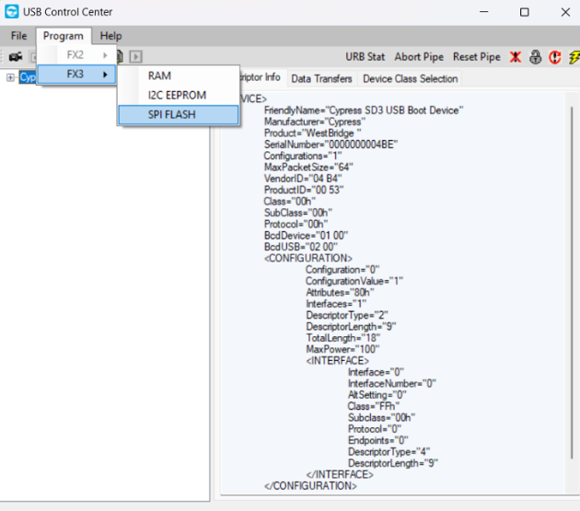
- If the board is successfully programmed, the boot mode disappears.
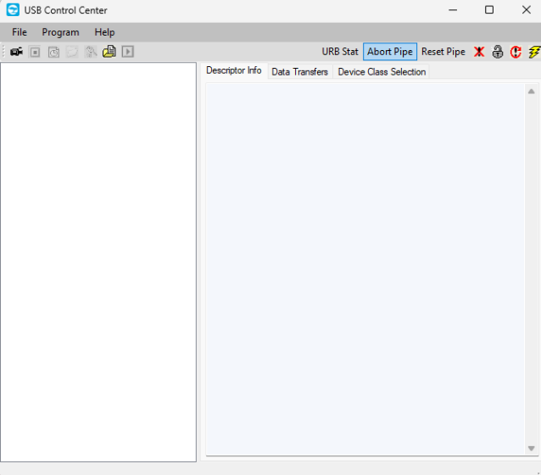
- Now the device is detected as OPTIM under camera section.

